**EXP NO 7**

**Experiment with different layouts and color schemes for an app. Collect user feedback on aesthetics and usability using GIMP(GNU Image Manipulation Program (GIMP)**

**App Layout & Color Scheme**

**AIM :**

The aim is to trial different app layouts and color schemes and evaluate user feedback on aesthetics and usability using GIMP.

Base Layout:



Added UI Elements:

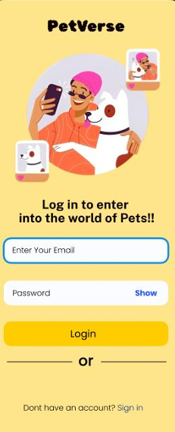

Organised Layers:

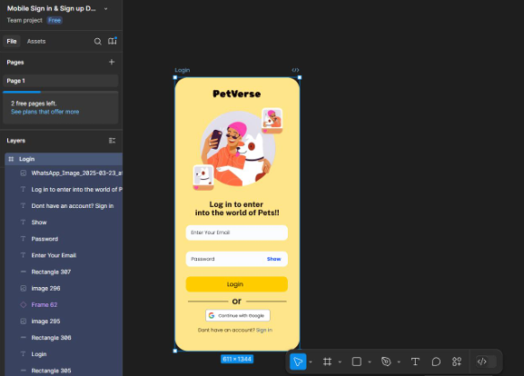

Experiment with Color Schemes:

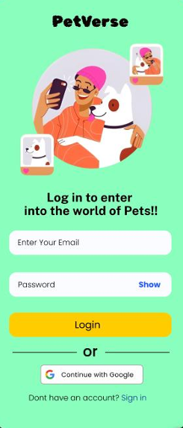

**Collected User Feedback**

Google Form Feedback Analysis: Yellow vs Green Variant

1. Which layout do you prefer?

Yellow Variant: 60%

Green Variant: 40%

Interpretation: Most users preferred the Yellow layout,

indicating it may be more visually appealing or better structured.

2. Which color scheme feels most professional?

Yellow Variant: 65%

Green Variant: 35%

Interpretation: The Yellow color scheme is seen as more

professional, potentially due to its brightness or better contrast.

3. How easy was it to find buttons and inputs?

Yellow Variant: 90%

Green Variant: 10%

Interpretation: Navigation and usability are clearly better in

the Yellow variant, with a very high ease-of-use score.

4. Which layout would you recommend to others?

Yellow Variant: 55%

Green Variant: 45%

Interpretation: While Yellow still leads, this is the closest

category, suggesting Green also has its merits worth exploring.

**Visual Representation**

As shown in the graph above, Yellow dominates across all

feedback categories, especially in usability and professional

appearance. Green, while liked by some, consistently ranks lower.

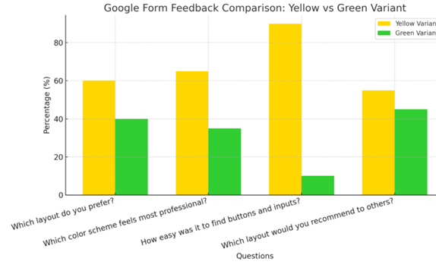

**One suggestion:**

It would be even better and more convenient if there were

additional login options like Google and Apple ID login buttons it

would make signing in faster and easier for users.

**➔ Iterate and Refine:**

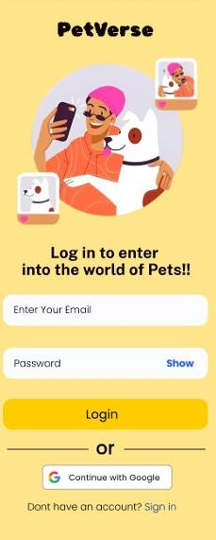

**A user-informed, visually polished mobile app layout was created using GIMP with variations in design and color scheme. Feedback-driven improvements enhanced both aesthetic appeal and usability.**